## Introduction

[DevOps](https://en.wikipedia.org/wiki/DevOps) is a principle to let development team and operation team work more closely together to create continuous integration of the underlying project. About [54% CEOs](https://www.pwc.com/us/en/tech-effect/ai-analytics/ai-business-survey.html) believe that AI technology boosts the performance of their company. How can AI help to continuously integrate?

As of today, AI is especially suited to simulate mental activities that generate textual output. DevOps teams can take advantage of AI Code generation, System Planning, System Testing, Feedback collection and FAQ answering. Generally speaking, AI is less helpful in system deployment or system operation right now as these phases require more human supervision.

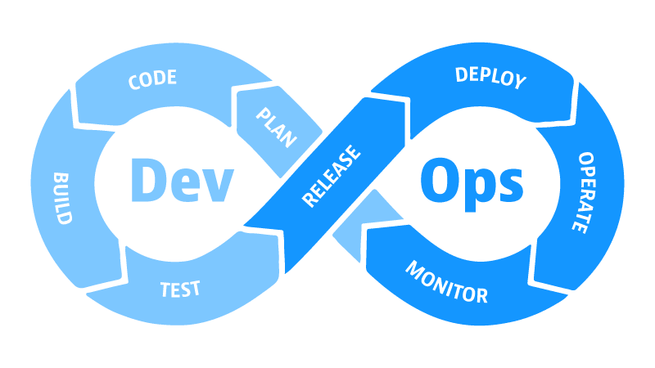

## During Development Phase

AI can provide code solutions to described problems to your desired programing language. This potential is helpful in a DevOps team where the developer has junior-level experience or comes from an operational background.

**Requirement Management:** Today, Chatgpt3 can break down complex problems into a tree-like structure. This is extremely useful for requirement analysis, where the development team can divide extensive functions into smaller categories. Then each developer will have explicit responsibilities for what his deliverables are.

**Architecture Design:** When starting with a big project, building a suitable framework for the project is crucial. AI can be used to identify potential bottlenecks in the system architecture and suggest ways to optimize them. This can be done by using deep learning algorithms to analyze the system architecture and identify areas of improvement.

**Pair Programming Partner:** AI code nowadays is good but needs to be more sophisticated to be left alone to code. It can act as a great coding partner to code with a professional-level developer to guide him, automate testing and validate the code. This new way of working is called [AI-Assisted Development](https://www.outsystems.com/glossary/what-is-ai-assisted-development/). It is excellent for developers who can frame the problem but don’t have the algorithmic knowledge of the solutions.

**Test and Debug:** AI tools can be used in automated debugging through pattern detection for an in-depth analysis, identification, and categorizing error types. This helps remove [manual testing](https://content.microfocus.com/software-test-automation-tb/top-mistakes?lx=wYdl7c&utm_source=techbeacon&utm_medium=referral&utm_campaign=7014J000000dVOkQAM&_ga=2.59573988.89091185.1676171353-1931313515.1676171345). The deep learning algorithm can easily flag errors and speeds up the debugging procedure. AI can also output the test case in natural language or as code. You can ask AI to write a general interface test for all your design program blocks to ensure you don’t miss any connections.

## During Operation Phase

AI can automate communication between DevOps teams, which usually would require manpower. It is crucial to have a good communication between the teams to remove [changing resistance](https://www.prosci.com/resources/articles/tips-for-managing-resistance-to-change). Some examples:

**Automatic Release Notification:** The developer can create an AI chatbot to automatically talk to the operator of the function once a new version has been released. This AI bot can be integrated centralized into workstation Chat programs such as [Slack](https://slack.com/)or [Lark](https://www.larksuite.com/).

**Consolidated Feedback Management:** The developer can also ask AI to talk to the operator to collect all the feedback and summarize them. This saves time for the developer to talk to each operator individually to get customized feedback. Then, AI can summarize feedback across multiple departments so that the developer maintains an overview of the entire feedback for the system.

**Smart FAQ Collector:**Once all feedback is gathered, consolidated and analyzed, the developer can build a FAQ from the data. The answers can be inserted into the AI chatbot to let it answer these questions to other colleagues. AI can help teams to identify frequently asked questions, and Dev teams can prepare their answers to AI.

**Continuous Monitoring:** AI can also provide insights into system performance, such as identifying areas of improvement or issues before they become problems.

## Summary

Today’s ChatGPT is the most recent breakdown in AI development. Right now, AI is a tool to help DevOps teams accelerate specific processes rather than a standalone agent who actively participates in the development cycle.

But also, remember other great non-AI tools that help make the development smoother. As long as these tools are suitable, whether

they are built using AI or non-AI methods doesn't matter.

Ultimately, DevOps team can leverage AI to mimic human mental activities to generate information in textual form.

Besides the development process, DevOps teams must also think of other [non-technical challenges](https://www.bunnyshell.com/blog/challenges-of-devops/) where AI is less capable of helping.